MEDIA RELEASE
22nd June 2026

Caribbean Economic Forum 2026 Positions the Caribbean Region as One of the World’s Most Strategic Investment Frontiers

The Caribbean's premier investment forum convened for the first time with global financial leaders representing more than US$24 trillion in institutional assets, lending capacity and balance sheet strength.
Bridgetown, Barbados – 22 June 2026. The inaugural Caribbean Economic Forum 2026 held 18-19 June at the Hilton Barbados Resort, brought together the most influential gathering ever assembled in the region, including global investors, sovereigns, international financial institutions, multilateral development banks, Wall Street investment banks, private equity firms, export credit agencies, central bank governors, government ministers, corporate CEOs and project sponsors, to focus exclusively on closing investment opportunities across the Caribbean.
According to Forum estimates, participating institutions collectively represented more than US$24 trillion in assets under management, lending capacity and institutional balance sheet strength. Hosted by ACERO CAPITAL, the Forum was designed as an investment platform, positioning the Caribbean as a unified, investment-ready market capable of attracting significantly greater flows of global institutional capital.
Consistent with the Forum's mission of connecting international investors and Caribbean leaders to accelerate investment in resilient and sustainable economies, CEF compressed months of investor origination and engagement into two intense days of structured dialogue, curated project presentations, private deal rooms and executive-level transaction meetings focused on transforming Caribbean project pipelines into bankable transactions, by pairing them with all the components of the capital stack and supplementing with credit and de-risking financial products.
The Forum drew speakers, delegates and institutional participants from across the Caribbean, Latin America, the United States, Canada, Europe, the United Kingdom, the Netherlands, the Middle East, Asia, Türkiye and Africa, reflecting the truly international character of the Forum and reinforcing the Caribbean's growing importance within global capital markets.
"For too long, the global community has misread the Caribbean as a collection of small, isolated markets. We completely reject that narrative. The Caribbean is one of the world's most strategic investment frontiers," said Gregory N. Hill, Founder of the Caribbean Economic Forum and Managing Partner at ACERO CAPITAL. "Our objective is to reposition the Caribbean as a unified investment destination; one capable of attracting institutional capital at scale through stronger project preparation, innovative financial structures, blended finance and strategic partnerships between governments, multilateral institutions and the private sector."
The Forum's opening plenary, "Ministerial Cap Table: Attracting Capital & Foreign Direct Investment at a National Scale," demonstrated the breadth of international leadership assembled for the event to discuss how Caribbean nations can compete more effectively for international investment. Participants included The Hon. Ryan Straughn, M.P., Minister of Finance of Barbados; The Hon. Lisa Jawahir, Minister for Agriculture, Fisheries, Food Security and Sustainable Development of Saint Lucia; H.E. Ana Irene Delgado, Ambassador and Permanent Representative of the Republic of Panama to the Organization of American States; Elee Muslin, Principal Officer for Blended Finance at IDB Invest in Washington, D.C.; and Graham Stock, Managing Director and Emerging Markets Senior Sovereign Strategist at RBC BlueBay Asset Management, London.
Equally significant was the "Governance Roundtable: Investible Resilience and Risk-Mitigating Instruments for the Caribbean" where the region's leading monetary authorities examined the policies, governance frameworks and innovative financial instruments required to strengthen investor confidence and expand private capital mobilisation across Caribbean economies. The session featured Kevin Greenidge, Governor of the Central Bank of Barbados; Larry Howai, Governor and Chairman of the Central Bank of Trinidad and Tobago; Dr. Gobind Ganga, Governor of the Bank of Guyana; Warrick Ward, Chief Executive Officer of the Financial Services Commission of Barbados; and Bexi Francina Jimenez Mota of MIGA, World Bank Group.
Throughout the two-day programme, senior executives from many of the world's foremost financial institutions, global asset managers, private equity investors, joined ministers, policymakers and leading entrepreneurs to explore practical solutions for mobilising capital into infrastructure, energy, climate resilience, technology, food security, logistics, financial services and the blue economy. This was a private-sector capital dominated focus, blended with participation by the MDBs, DFIs and ECAs to name a few, which included the Green Climate Fund given their focus on sustainable investing. Clinton White of Counselor Global Solutions reinforced that “the architecture of CEF aligns capital with resilience.”
The Caribbean Economic Forum established and secured its unique place as a new model for accelerating investment into the Caribbean and positioning the region as one of the world's most attractive destinations for sustainable, long-term capital.

About the Caribbean Economic Forum
The Caribbean Economic Forum (CEF) is the Caribbean's leading investment forum, dedicated to mobilizing institutional capital, accelerating deal origination and fostering strategic partnerships that drive sustainable economic growth across the region. Hosted by ACERO CAPITAL, the Forum convenes global investors, governments, multilateral development banks, development finance institutions, commercial banks, private equity firms, export credit agencies and corporate leaders to transform investment opportunities into executable transactions. Through its distinctive model of high-level dialogue, curated investor engagement and transaction-focused programming, CEF serves as a gateway connecting Caribbean opportunities with the world's largest pools of capital. Learn more at www.caribbeaneconomicforum.com

Media Contact
Caribbean Economic Forum
Website: www.caribbeaneconomicforum.com
Email: caribbeaneconomic@gmail.com

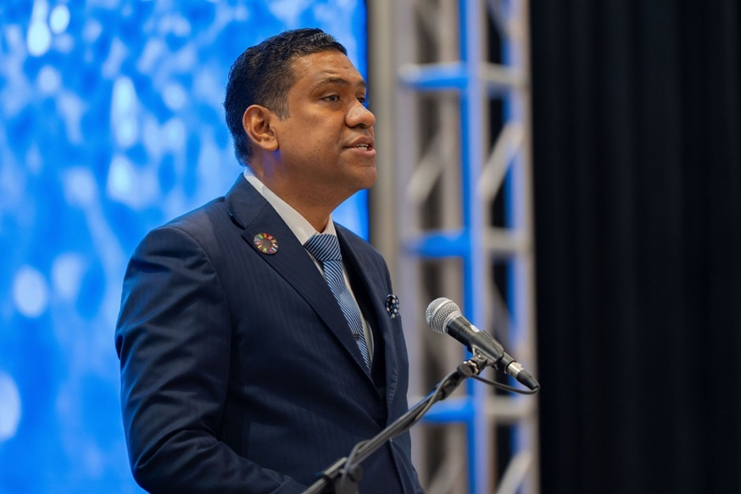
Gregory N. Hill – Founder, Caribbean Economic Forum & Managing Partner, ACERO CAPITAL

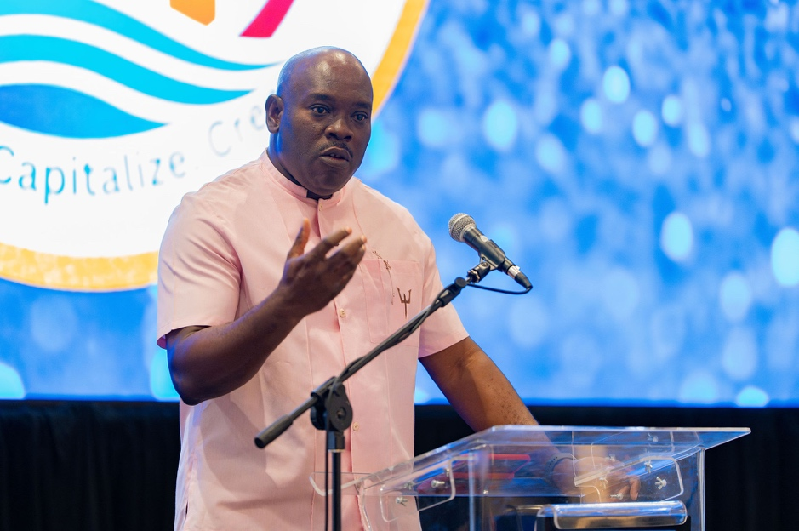
Hon. Ryan Straughn, M.P., Minister of Finance of Barbados
delivers the Feature Address at Caribbean Economic Forum 2026 at Hilton Barbados Resort,
18th June 2026

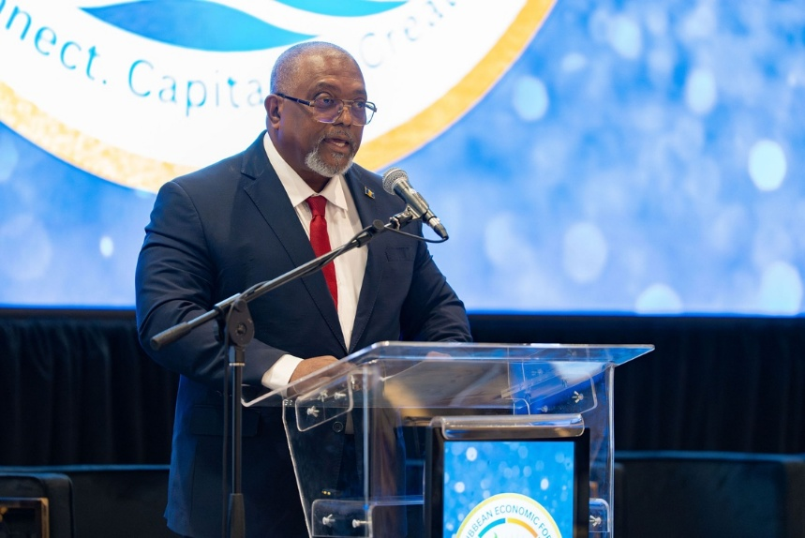
Hon. Indar Weir, M.P. Minister of Public & Private Investment delivers Opening Remarks at Caribbean Economic Forum 2026 at Hilton Barbados Resort, 18th June 2026

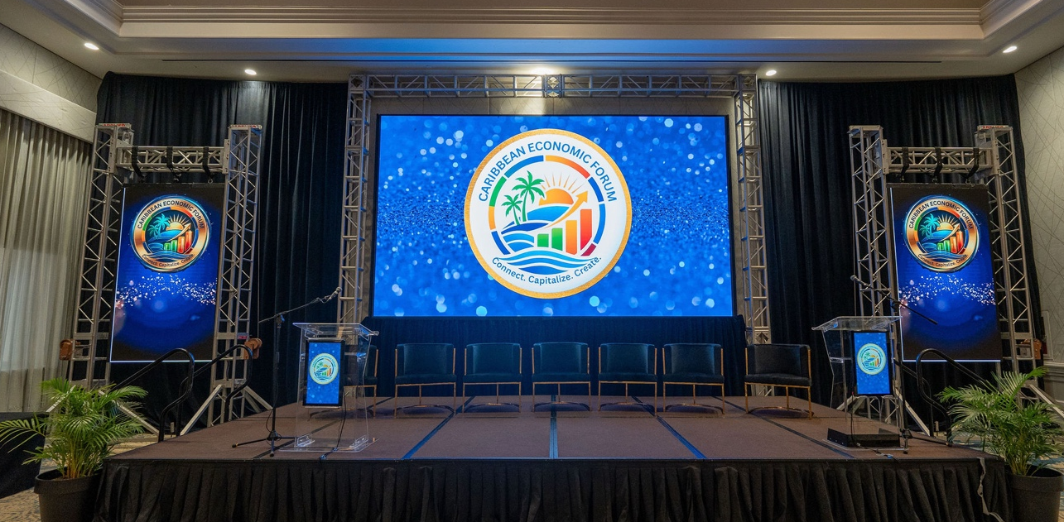
Proposed Caption: Stage set for positioning the Caribbean region as a strategic global investment frontier with the pioneering launch of the Caribbean Economic Forum - a first for the region. 18th June 2026.

